**Automated Analysis of Unregistered Multi-View Mammograms With Deep Learning**

Gustavo Carneiro, Jacinto Nascimento, and Andrew P. Bradley

**Abstract**

We describe an automated methodology for the analysis of **unregistered cranio-caudal (CC) and medio- lateral oblique (MLO)** mammography views in order to estimate the patient’s risk of developing breast cancer. The main innovation behind this methodology lies in the use of deep learning models for the problem of jointly classifying unregistered mammogram views and respective segmentation maps of breast lesions (i.e., masses and micro-calcifications). This is a holistic methodology that can classify a whole mammographic exam, containing the CC and MLO views and the segmentation maps, as opposed to the classification of individual lesions, which is the dominant approach in the field. We also demonstrate that the proposed system is capable of **using the segmentation maps generated by automated mass and microcalcification detection systems, and still producing accurate results**. The semi-automated approach (using manually defined mass and microcalcification segmentation maps) is tested on two publicly available data sets (**INbreast and DDSM**), and results show that the **volume under ROC surface (VUS)** for a 3-class problem **(normal tissue, benign, and malignant)** is over **0.9,** the **area under ROC curve (AUC) for the 2-class “benign versus malignant” problem is over 0.9,** and for the **2-class breast screening problem (malignancy versus normal/benign) is also over 0.9**. For the fully automated approach, the **VUS** results on **INbreast is over 0.7, and the AUC for the 2-class “benign versus malignant” problem is over 0.78, and the AUC for the 2-class breast screening is 0.86.**

We propose a new methodology that analyses a **two-view mammographic exam in a fully automated and holistic manner.** The main innovation behind our approach is the use of a deep learning model that receives as **input, both the CC and MLO** mammographic views and the **segmentation maps of the breast lesions** (i.e., masses and MCs) and outputs **a classification of the exam into normal tissue, benign or malignant** (hereafter, we refer to the normal tissue class as negative). The proposed methodology faces the following challenges: **1) deep learning models need annotated datasets that are orders of magnitude larger than what is currently available in medical imaging, and 2) the joint analysis of unregistered multi-view (CC and MLO) and multi- modal inputs (images and segmentation maps) require high- level features that represent the global information present in those inputs.**

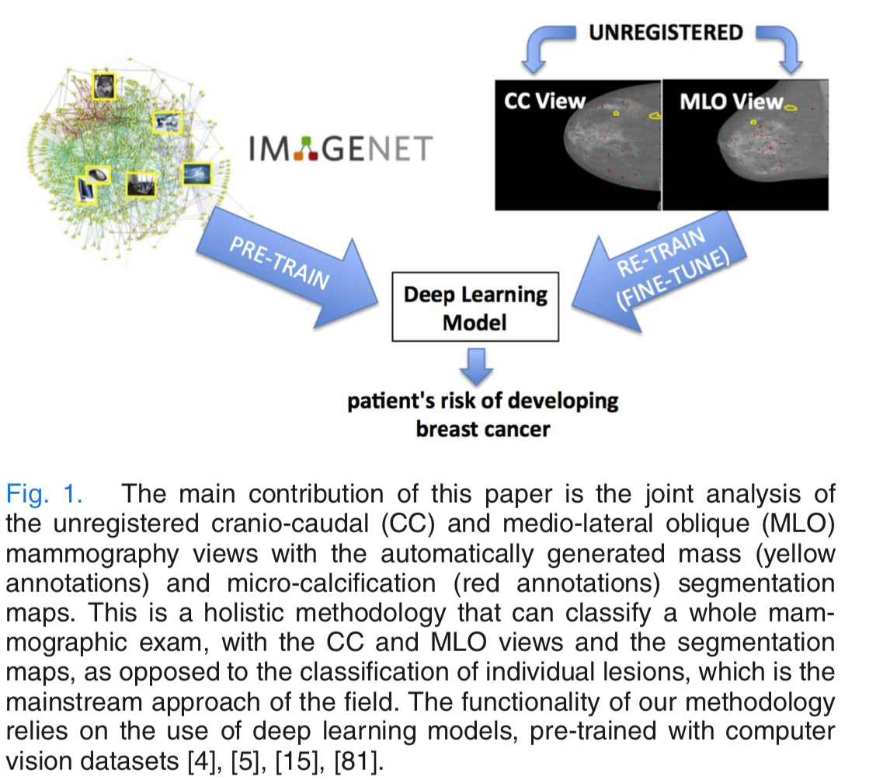

The first challenge is addressed with **transfer learning** where the deep learning model is **first trained with a large annotated computer vision dataset** , and then **re- trained (or fine-tuned) using small annotated mammogram datasets.**In parallel to the development of our own work, other similar approaches have been proposed, such as the use of ImageNet to pre-train a deep learning model that identifies pathologies in chest x-ray images, or the thorough study produced on the use of non-medical image datasets to pre-train deep learning models to be used in various medical image analysis tasks.

The second challenge is solved with the **use of the high-level features produced by the deep learning models**, where we assume that the high-level nature of the deep learning features reduces the need for a low-level matching (registration) of the input data. After the development of our original work, which is extended in this paper, there have been relatively similar proposals that classify whole or large patches of mammograms using deep learning models.In fact, We test two versions of our proposed methodology:

**A semi-automated** approach that uses the **manually defined seg- mentation maps of the lesions, and a fully automated approach that uses the lesion detection results** from Dhungel et al. [22] and Lu et al. [55]. Compared to previously proposed methods in the field, **our model is able to automatically learn the features that are optimal for the classification problem** (as opposed to hand-crafting them) **and to process a full mammographic exam in a holistic manner**, **without making lesion independence assumptions**. The semi-automated approach is assessed on two publicly available datasets (**INbreast and DDSM**), where it produces state of the art **results for the 3-class and 2-class classification problems.** The fully automated approach assessed on INbreast shows a competitive result with respect to the semi-automated approach on the same classification problems.

This paper is an extension of two preliminary works , where the innovations consist of: 1) **the fully automated methodology based on automatically detected masses and MCs, 2) a study on the stage of the deep learning model to merge the different modalities, 3) a study involving a larger set of data augmentation, and 4) a new way of joining the input images as 3-D inputs rather than a collection of 2-D data**.

In this paper, **the main novelty consists of the use of unregistered multi-view inputs, where images and segmentation maps are processed in a holistic manner** (our original paper on the holistic analysis was also developed in parallel to the approaches cited above - note that even though we use detection of lesions, we process the whole image and not each lesion independently). We also explore the transfer learning approaches mentioned above to deal with the limited amount of training samples.

